**Project Design Phase-II**

**Technology Stack (Architecture & Stack)**

|  |  |
| --- | --- |
| Date | 03 October 2022 |
| Team ID | PNT2022TMIDxxxxxx |
| Project Name | Efficient Water Quality Analysis and Prediction using Machine Learning |
| Maximum Marks | 4 Marks |

**Technical Architecture:**

The Deliverable shall include the architectural diagram as below and the information as per the table1 & table 2

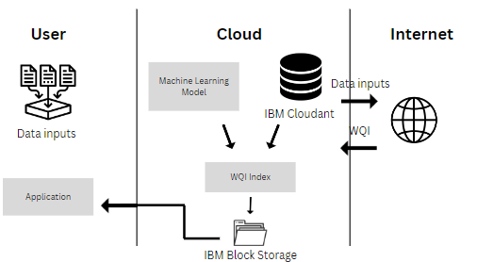

**Table-1 : Components & Technologies:**

|  |  |  |  |
| --- | --- | --- | --- |
| **S.No** | **Component** | **Description** | **Technology** |
|  | User Interface | Web User Interface | HTML, CSS, JavaScript |
|  | Secure Login | Login using 2 factor authentication | Google Authenticator |
|  | Query Result | Help users get WQI quickly | IBM Watson Assistant |
|  | Database | To store all the data inputs of the water sample. | MySQL |
|  | Cloud Database | Database Service on Cloud | IBM DB2 |
|  | File Storage | File storage requirements | IBM Block Storage |
|  | External API-1 | To fetch user’s location | Geo-Location API |
|  | Machine Learning Model | Purpose of Machine Learning Model | Water Quality Measurement Model |
|  | Infrastructure (Server / Cloud) | Application Deployment | Cloud Foundry |

**Table-2: Application Characteristics:**

| **S.No** | **Characteristics** | **Description** | **Technology** |
| --- | --- | --- | --- |
|  | Open-Source Frameworks | open-source framework | Flask |
|  | Security Implementations | To provide a secure framework | SHA-256 |
|  | Scalable Architecture | To Ensure scalability of architecture | Customer reviews. feedbacks |
|  | Availability | The availability of application for the users on the cloud | IBM Cloud |
|  | Performance | To make sure the performance isn’t compromised | Black and white testing |